**React JS**

**Episode 4:**

**Notes:**

we can write css in 3 ways

External CSS - adding css file to html

Inline css :

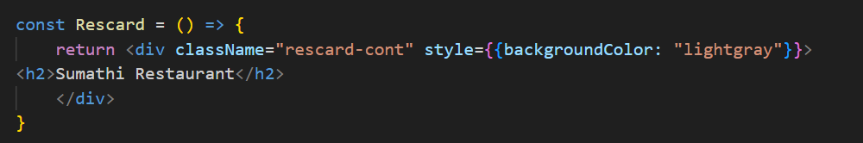

Internal Css:

Stylecard is an object

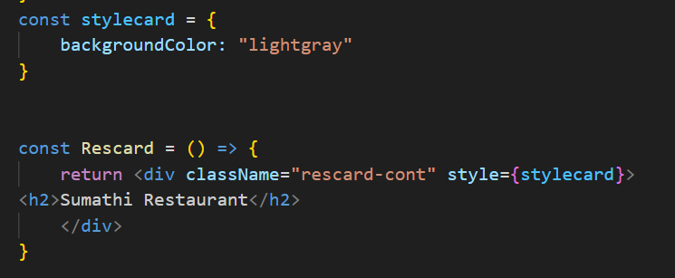

**Props:**

Passing argument to a function

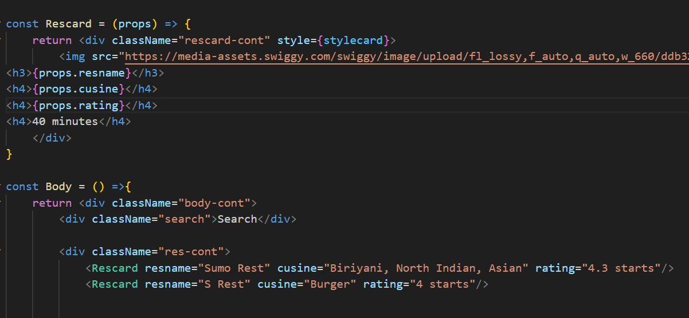

**Config driven UI:**

We can use same website for different places with different designs by using config[ Json - write code based on place and offer ]

Map method:

Instead of this:

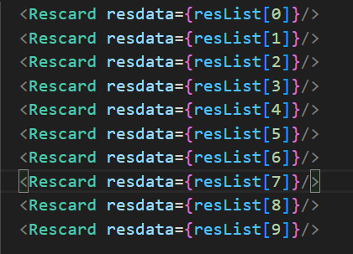

We used map method:

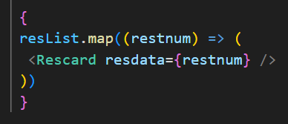

To avoid the below warning, we should use key property [unique id to all elements]

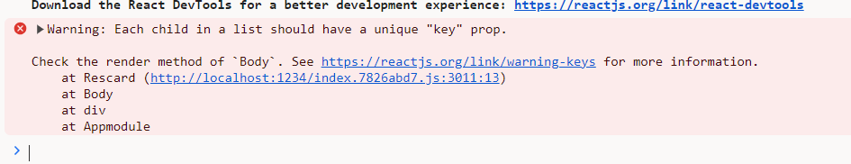

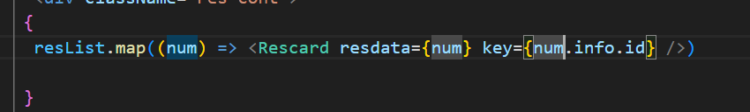

Note:

We shouldn’t use ‘index’ as key. React may confused.

